# PERT CHART

PERT stands for PROGRAM EVALUATION & REVIEW TECHNIQUE.

A chart is a tool that shows project as network diagram. It was develop in 1950 for US Navy to reduce both the time and cost required for complete a project.

## Steps in PERT Planning Process:

1. Identify the specific activities and milestones.
2. Determine the proper sequence of activities.
3. Estimate the time required for each activity.
4. Determine the critical path.
5. Update the PERT CHART as the project progress.

## Benefits of PERT- (PERT is useful because it provides the following information)

1. Expected product completion time.
2. Probability of completion before a specific date.
3. The critical path activities that directly impact the completion time.
4. Activity start & end dates.

# PERT CHART (DIAGRAM)

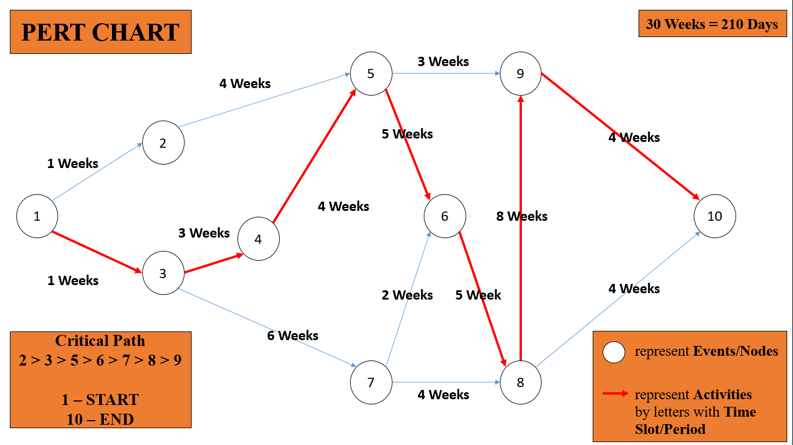

|  |  |  |  |
| --- | --- | --- | --- |
| **EVENTS/NODES** | **ACTIVITES** | | **Critical Path** |
| **EVENT occurred in TIME SLOT** | **30 WEEKS** |
| 1. Start | 1 – START – 3 | WEEK 1 | **1** |
| 2. Feasibility Study | 3 – Feasibility Study – 4 | WEEK 3 | **3** |
| 3. Requirement Analysis | 4 – Requirement Analysis – 5 | WEEK 4 | **4** |
| 4. Design | 5 – Design – 6 | WEEK 5 | **5** |
| 5. Coding/Algorithm | 6 – Coding/Algorithm – 8 | WEEK 5 | **6** |
| 6. Testing | 8 – Testing – 9 | WEEK 8 | **8** |
| 7. Maintenance | 9 – End – 10 | WEEK 4 | **9** |
| 8. End | 10 – End – COMPLETED | WEEK 4 | **10** |

# Project Duration

|  |  |  |  |
| --- | --- | --- | --- |
| **TASK NAME** | **DURATION** | **START DATE** | **END DATE** |
| 1. Feasibility study | 3 WEEKS | 8/1/2020 | 28/01/2020 |
| Technical Feasibility | 1 WEEK | 8/1/2020 | 14/01/2020 |
| Economical Feasibility | 1 WEEK | 15/01/2020 | 21/01/2021 |
| Behavior Feasibility | 1 WEEK | 22/01/2021 | 28/01/2020 |
| 2. Requirement Analysis | 4 WEEKS | 29/01/2020 | 25/02/2020 |
| Requirement Gathering | 1 WEEK | 29/01/2020 | 4/2/2020 |
| Group Interaction | 2 WEEK | 5/2/2020 | 18/02/2020 |
| Analysis | 1 WEEK | 19/02/2020 | 25/02/2020 |
| 3. UI-Design | 5 WEEKS | 26/02/2020 | 31/03/2020 |
| Firewall | 1 WEEK | 26/02/2020 | 3/3/2020 |
| Honey-pot | 1.5 WEEK | 4/3/2020 | 14/03/2020 |
| D-dos | 1 WEEK | 15/03/2020 | 21/03/2020 |
| Log Management | 1.5 WEEKS | 22/03/2020 | 31/03/2020 |
| 4. Coding / Algorithm | 5 WEEKS | 1/4/2020 | 5/5/2020 |
| Firewall | 1 WEEK | 1/4/2020 | 7/4/2020 |
| Honey-pot | 1.5 WEEK | 8/4/2020 | 18/04/2020 |
| D-dos | 1 WEEK | 19/04/2020 | 25/04/2020 |
| Log Management | 1.5 WEEKS | 26/40/2020 | 5/5/2020 |
| 5. Testing | 8 WEEKS | 6/5/2020 | 26/05/2020 |
| Unit Testing | 1 WEEK | 6/5/2020 | 12/5/2020 |
| Integration Testing | 1 WEEK | 13/05/2020 | 19/05/2020 |
| System Testing | 1 WEEK | 20/05/2020 | 26/05/2020 |